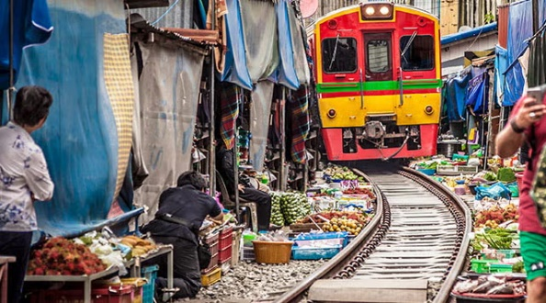
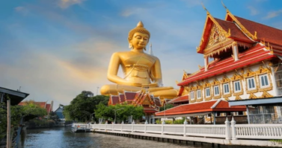
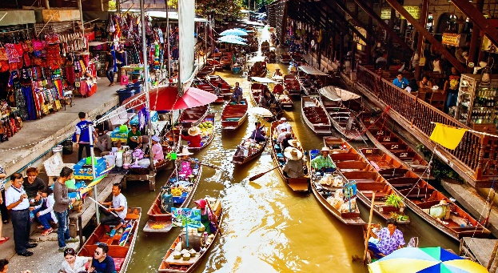
Bangkok -HuaHin 5day/4night (PRIVATE)

Tour Code: HHN – 05

Tour Highlights: Damnean saduk Floating market / Zucata Sheep fram / Songwat Street Art

Day 01 Flight arrive to/BANGKOK
Assemble at airport and take your flight to Bangkok, Visit to Wat Paknam Pasi Charoen ,
Bantadthong night Street food
Shopping and enjoy Local food with shopping at Jood fair Night Market , Dinner by own

Day 02 BANGKOK/HUA HIN (B/L/D)
*DamnoenSaduak Floating Market (include boat ride) here you will be fascinated by boats of various shapes and sizes used by local merchants to ferry their goods
*Maeklong Railway Market: This is a unique market that is held every day literally on the rail tracks.
*Wat Bang Kung: The small chapel that is completely enclosed within the roots of a banyan tree called Bot Prok Po.
It is almost like the tree itself is the pillars of the temple and that without the roots the chapel would fall down.
*Zucata Sheep Farm: It makes a pleasant stop for you to get right in there amongst the cuddly sheep, feed them some grass, or offer a bottle of milk to a little lamb. It’s a great place to stretch one’s legs and take some deep breaths of country air after escaping the bustling, booming capital.

*Venezia, Top ways to experience The Venezia Hua Hin & Cha-am.

Hua-Hin Night Market

Day 03 HUAHIN (B/L/D)
*Hua Hin Railway Station: One of the country’s most beautiful train stations marked by its meticulous details in architecture.
*Wat Huay Mongkol: This Buddhist temple is home to the world’s largest
statue of Luang Phor Thuad, a legendary southern, Thai monk revered for his enlightenment and ability to perform miracles. Many believe that the amulets created in his image guarantee safety in times of.
*After lunch visit Khao Takiap viewpoint
HUA-HIN BEACH, Own activity, The Secret Café , Shopping Hua-hin blue port or Villa Market

Day 04 HUA HIN/BANGKOK (B/L/D)
1000 sook Farm and restaurant.
SONGWAT Road street art,
* Shopping Platinum mall, Big C shopping center OR CENTRAL PARK *new shopping mall
*Four Face Buddha，Known by international visitors as the Phra Phrom, the Hindu Brahma, the statue lies in one of Bangkok's busiest locations.

Day 05 BANGKOK-Departure (B)
*Free & Leisure till transferred to the airport for your flight to your Swiss home
Tour Code C: HHN -05
